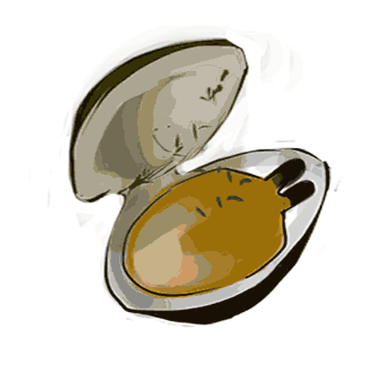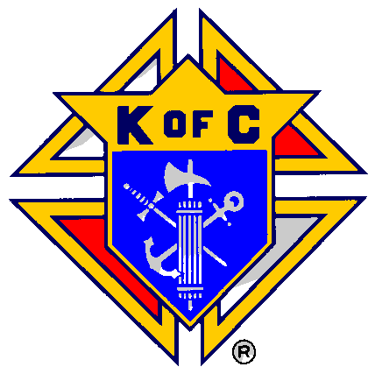

Bristol Council 379
Clam boil Dinner to support
Robotics Program
Our Lady of Mount Carmel School

Saturday May 18th
A Steak fry option is available this year!!!
6PM - $25
Kids Meal $5
Limited seats - Reserve early!!!!
Contact Past Grand Knight Warren Rensehausen
wrensehausen@hotmail.com
401-200-1047

